Groundstation Infrastructure Requirements Document

|  |  |  |  |
| --- | --- | --- | --- |
| Groundstation Requirements Document | | | |
| ID | Description | Requirement | Method of Verification |
| GR-001 | Power Accessibility | System must be powered at all times. | Check to see if a Plug is available and willing to be dedicated for groundstation purposes |
| GR-002 | Minimum Access Time | Average Access time must exceed 300s per pass. | STK simulation, influenced by surrounding environment at groundstation |
| GR-003 | Signal Attenuation | Signal Attenuation due to atmospheric, ionospheric and Line of sight Obstruction must be less than 3dB | Link Budget Analysis, With recommendations from ITU on Ionospheric and atmospheric losses. |
| GR-004 | Signal Interference | Must not interfere with any signals incoming, must not have any equipment surrounding that will be operating in the Tx/Rx range | List of equipment being used currently, including any frequency ranges being used. |
| GR-005 | Wi-Fi reliability | Must have reliable Wi-Fi network to connect to campus (Wired?) | Prior experience, ask Peter Brown how reliable the network has been. |
| GR-006 | Maintenance and Installation Safety | How to install/ maintain the groundstation equipment. | Structural analysis / recommendations from personnel currently maintaining the subject area |
| GR-007 | Cost | Must meet specified budget | Must meet specified budget |

Groundstation Infrastructure Justification

# Power Accessibility (GR-001):

Power accessibility is critical when operating a groundstation because transmission time is limited by the orbit of the desired satellite. Figure 1 below shows example communication periods between satellites and earth, where the average for Toronto being 45 minutes per day. The key reason in having a stable power connection is that space missions are expensive undertakings, where mission life can be limited due to component life or restrictions by other organisations such as launch providers or NASA. This implies that every missed opportunity to pull data from a satellite is a major concern. Missing a single contact time in Toronto has the implication of the reduction of available scientific data between 3% to 19%.

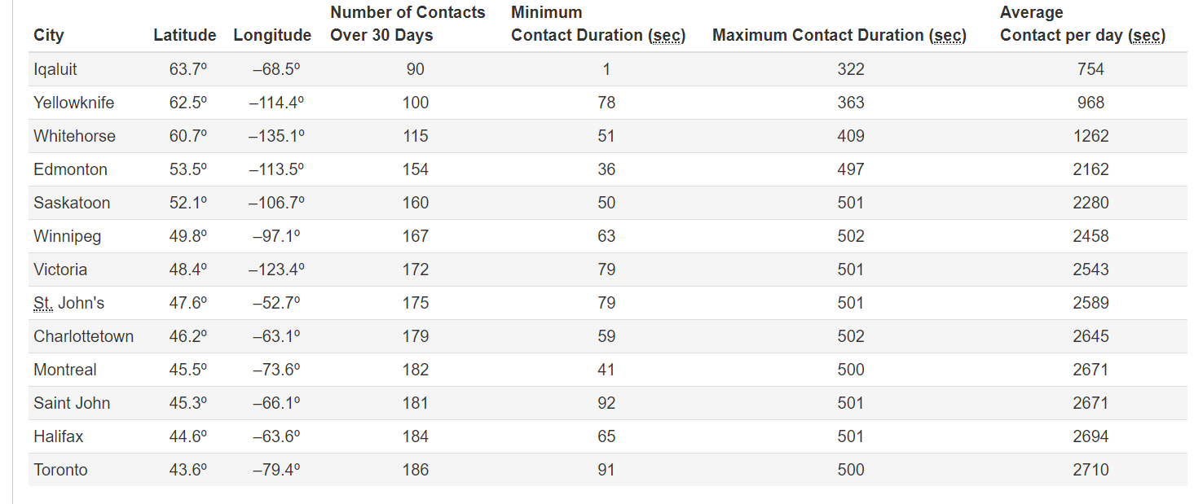

## Figure 1: Example Access Times for Canadian Cities provided by CSA [1]

Another factor to ensure the ability of the groundstation to always be operational is the limited power generation available aboard spacecrafts. Spacecraft functionality is severely influenced by the available power of a system. Limited power directly influences the power intensive communication equipment in order to transfer data from space to earth. Often times trade-offs have to be made based on available power and how often to transmit. With satellite communication being limited, it is imperative that groundstation be available when the satellite is available.

# Minimum Access Time (GR-002):

Access time is defined as the period of time in which the orbiting satellite can communicate with the desired groundstation. Any disturbances or environmental factors which can negatively impact the access time should be brought to a minimum. The main foreseen disturbances whose impact should be reduced are: the line of sight obstruction from trees and surrounding infrastructures. A paper from the International Journal of Advanced Computer Science and Applications by Shkelzen Cakaj ,Bexhet Kamo, Algenti Lala and Alban Rakipi explain that the area of coverage is considered to be the largest when a complete field of view is considered, however it is often that the link budget dictate a smaller field of view due to signal strength constraints [2]. The paper recommends an elevation angle between 2 and 10 in order to have a good trade-off between maximizing the access time and minimizing required building infrastructure to avoid obstructions to the field of view for the groundstation antenna. Figure 2 below shows an example area of coverage for a groundstation with respect to an orbiting satellite.

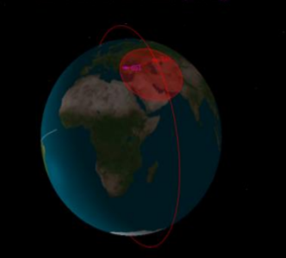

## Figure 2: Groundstation under Low Earth Orbit coverage area

A simulation shows in figure 3 by Shkelzen Cakaj, Bexhet Kamo, Algenti Lala and Alban Rakipi also shows the percentage of coverage as a fraction of earth at four different low earth orbit heights; 600, 800, 1000 and 1200km. The simulation also shows different elevation angles which show the reduced area of coverage which vary between 0 and 10, with a clear indication that the area of coverage reduces with a larger elevation angle. It is important to remember that the communication time is directly related to the area of coverage, therefore it is in the best interest to allow the largest area of coverage by minimizing the impact of any line of sight disturbances.

# Signal Attenuation (GR-003):

While elevation angles influence the access time, it is also important to consider the affects of elevation angle on signal strength as well. Given the information from the minimum access time it indicates that having the largest field of view is recommended, however the affects of atmospheric attenuation, ionospheric attenuation and free space path loss haven’t been taken into account. Atmospheric affects are mainly comprised of water vapor an oxygen loss as the radio wave propagates through the atmosphere [3], while ionospheric affects are mainly comprised of losses due to faraday rotation and scintillation [4]. Faraday rotation losses can be almost completely negated with the correct choice in antenna polarization while ionospheric scintillations are losses due to changes in the refractive index of the ionosphere which cause refraction or reflection of radio waves, especially signals under 3GHz in frequency [4]. Figure 1 om the appendix shows an example of the calculated signal strength loss due to atmospheric attenuation, a recommendation by the International Telecommunication Union (ITU) [4]. It can be seen that atmospheric loss increases as elevation angel decreases, a direct contrast to the ideal situation where the area of coverage is maximized and the elevation angle is minimized.

Free space path loss follows the exact same trend where signal strength attenuates as the elevation angle decreases. Signal strength inside of the Friis transmission equation, which characterizes satellite to groundstation communication, is inversely proportional to the distance which is travelled. The slant range in space communication is the line of sight distance along the slant direction between two points which are not at the same level relative to the geodetic datum [5]. In essence the distance travelled by the radio wave increases as the elevation angles decreases, which leads to larger signal attenuation. This implies that a trade-off between signal strength and access time must be made, which is where the recommendation between 2 and 10° from Shkelzen Cakaj, Bexhet Kamo, Algenti Lala and Alban Rakipi comes into consideration. While approaching a 0 elevation angle increases the theoretical access time, the signal strength will be so low the groundstation receiver will be incapable of discerning whether the radio wave is important information, or simply noise. A safe worst case elevation angle in to plan around is 5, also shown in an example by the Canadian Space Agency for a 400 MHz radio wave link budget in a webinar named “Satellite communications 101” [5].

# Signal Interference (GR-004):

Signal interference is also important to take into account, in order to prevent the groundstation from interfering with other projects and to prevent other projects interfering with the groundstation. It is acknowledged that many locations that might be favorable might already have projects that work in the same frequency bands as the target range for the groundstation. In an attempt at cooperation, a request of a list of occupied frequencies which cannot be operated at should be presented. Properly planning such that a location can be used key in order to push forward new and innovative projects, while leaving room to allow further growth in the future. Having a list of occupied frequencies should allow for future planning as well, building in the capability of operating at other popular frequencies for future projects.

The current project is attempting to operate in a frequency range somewhere in the 430-440 MHz region, ultra high frequency range (UHF), while thinking of having built in capabilities to expand to 2GHz range as well, S-band range. The current 400Mhz range of operation is needed to support satellite communications which is severely limited by the amount of power generated by the target satellite. The 2 GHz communication band is able to achieve a higher data rate, at the cost of needing more power to transmit and receive. The current target satellite is of the 2U size, approximately 10cm x10cm x 20cm, however building in capabilities to communicate with larger satellites is recommended if future projects are procured, such as a 6U which is much more capable of supporting the higher data rate 2Ghz communication band.

Even building in the support to allow for extra communication bands is recommended, with the cost of adding a couple extra ports and data lines insignificant compared to the cost of building the groundstation or satellite itself. Allowing a groundstation the privilege to operate on Western procured grounds not only strengthens the CubeSat project, however it also allows further growth for the CPSX institute with the ability to look into further space satellite missions with either current capabilities, or a reduced cost of out of band frequencies ranges. Allowing growth for CPSX is key to allow students and researches the capability of performing space exploration, research, space operations training and outreach to other students when a real-life space operations station can be demonstrated. Countless exciting possibilities open up with the building of a groundstation to be operated by Western, even when a satellite is not being operated by Western it will be able to pull data from other 400 MHz satellites operating in the amateur band range. This is key when other mission concepts are in development, training on receiving telemetry data can continue with other satellites as well.

# Wi-Fi Reliability (GR-005):

With satellite orbits being uncontrollable from a satellite operations perspective, planning around the satellite orbit becomes crucial. Regardless of the time of day, communications between satellite and groundstation must be achieve. Having a stable Wi-Fi connection is critical to operating a satellite over a mission life of 6 months – a year, especially when operations will happen during atypical hours of the day. Automation has become critical for many projects lately, with Wi-Fi being a main driver behind remote automated routines. Having a remote operation station on Western’s main campus is almost necessary for supervising the CubeSat as well as training other students on satellite communications. Providing the experience to a group of students becomes easier and more effective if visual or real-life examples can be shown. Removing barriers such as transportation requirements or timing to accommodate with students’ classes are just some of the problems which can be solved with a remote automated control station.

# Maintenance and Installation Safety (GR-006):

No groundstation can be complete without some sort of hardware, having access to that hardware for maintenance as well as installation is key to creating and maintaining a groundstation for many years to come. Safety is of course the highest priority amongst all requirements, which has to be treated with the utmost concern.

# Cost (GR-007):

Trade-offs can of course be made between being able to safely install and maintain hardware versus the cost of the proposed operation. Having a realistic cost to installing the groundstation is important for initial installation and any modifications for future projects as well. Having initial installation costs exceed budgeted plans will either compromise the safety of the installation crew and future students or lead to the failure of the CubeSat project due to unplanned attenuations or incomplete or compromised assembled products. Having the maintenance of the hardware be as low as possible is key in order to keep the groundstation running as well, which allows for the creative freedom of satellite communications for students enrich the experience which can already be obtained from CPSX as well as Western engineering.

Elgin Observatory Options

The following options below are for groundstation placement at Elgin observatory, each will be verified with the specified requirements document. Elgin observatory is an optimal location for a Western based groundstation because; it has tall edifices, has ample room for groundstation equipment, stable Wi-Fi connection for off campus communications and has the capability of powering groundstation equipment.

# On top of Elgin Observatory:

## Power Accessibility:

Placing the groundstation on top of Elgin Observatory should offer available power with minimal modification to the building. Threading a powerline through the building should be possible, however depending on availability of outside power already, slight holes / weather proof cabling and protections will be required to power outside equipment. Obtaining power is possible, convenience of available power might be slightly lower than other options.

## Minimum Access Time:

Access time would be maximized when placing receiving and transmitting antenna on top of Elgin Observatory. Elgin observatory is the tallest building that can be seen in its immediate surrounding, preventing other trees and edifices from obstructing signal strength and allowing a larger coverage area for receiving satellite data. A picture of Elgin Observatory has been included in the appendix in figure 2 and a view from the deck of the observatory can be seen in figure 3. Notice the tree line and other observation stations with reference to the observatory itself.

## Signal Attenuation:

By covering a larger coverage area, signal attenuation will increase due to certain effects detailed in the justification section which rely upon elevation angle. This configuration will be limited more by signal strength from the link budget rather than environmental obstructions. Very little will need to be done to modify the surroundings with antenna placement on top of the observatory.

## Signal Interference:

Signal interference is highly dependant upon other equipment surrounding the observatory, meeting this criterion will enable the possibility of building a groundstation. Failing this criterion will cause every configuration of the building the groundstation at Elgin Observatory to fail. No configuration will be better for this purpose.

## Wi-Fi Reliability:

Wi-Fi reliability is essential to being able to transmit data to a remote campus operations and control room. Being able to transmit data to a computer by radio wave or through ethernet will be key for this operation. In consideration that communication will likely have to happen via ethernet, cabling becomes an issue. Having a connection between the observatory and the house which can communicate with campus is crucial. Expenses with either laying the cable underground or weatherproofing the cable will be necessary. Threading the cable through the building or on top of the building depending on where transceiver is placed also becomes a factor.

## Maintenance and Installation Safety:

Installation and maintenance safety are the most worrisome with this option. While Elgin observatory offers great coverage, placing the antenna could be expensive. Figure 4 in the appendix demonstrates the state in which the Elgin observatory’s sun deck is currently in. It is evident that the deck is in poor state, making it dangerous for students to walk past it for demonstration purposes or for maintenance if weather such as ice gets stuck on top of antennas. Seeing the condition in which the top deck of the observatory is in is also crucial, if it is even able to support the weight of antenna and supporting equipment safely.

## Cost:

The cost of fixing the observation deck is potentially a costly one, however with respect to building a custom platform it might be less costly. Bringing the observatory back into use also has its own merits, such a facility should be put to use by the CubeSat project or another project. The current use of the facility is mainly storage, something that should be changed. Such a facility could have a wide variety of uses, one of them being rooms and equipment dedicated towards satellite communications. Increasing the cost of the project could lead towards a renewal of the uses for the Elgin observatory, which is currently not being used towards a significant space project.

While needing a large minimal cost in order to bring the facility into an operable state, it also has the largest potential into turning into a project Western and CPSX can be truly proud of. Taking an initial step is necessary in order to truly view the value such a project could offer, not just in the present but for the foreseeable future as well.

# On top of Elgin Observatory House:

## Power Accessibility:

Having power on top of the Elgin observatory house is likely to be the most accessible and realizable. With having equipment already outside the house, it has already been proven that that such power can be readily achieved. Obtaining power with this configuration is likely the be the most convenient.

## Minimum Access Time:

The access time with the house configuration is likely to be the most troublesome. Having such a close tree line to the house poses issues with area of coverage and allowable elevation angle. Figure 6 and 7 of the appendices shows the house relative and close objects relative to the treeline. Having such a facility will be a compromise to the overall data that can be achieved from the satellite.

## Signal Attenuation:

Signal attenuation will not likely be the driving factor behind such a groundstation placement. A larger minimum elevation angle will be needed in order to prevent the near treeline from affecting the signal propagation. The minimum elevation angle will likely be above 5, even being as high as 10 or 15.

## Signal Interference:

Signal interference is highly dependant upon other equipment surrounding the observatory, meeting this criterion will enable the possibility of building a groundstation. Failing this criterion will cause every configuration of the building the groundstation at Elgin Observatory to fail. No configuration will be better for this purpose.

## Wi-Fi Reliability:

Wi-Fi reliability will likely be the simplest in this configuration. Threading an ethernet cable to the appropriate equipment will be the easiest. Most of the electronics could be stored inside the house itself, reducing the need for expensive cabling while keeping reliable contact with campus.

## Maintenance and Installation Safety:

Safety concerns with this type of configuration is likely to be minimized as well. Having accessible equipment in case of emergency is always a factor which cannot be understated. The condition of the house seems capable of hosting the desired equipment, the house also has a structural integrity which the Elgin observatory cannot offer without any maintenance.

## Cost:

The cost of maintaining and installing the equipment will be the least expensive inside this configuration. While not being ideal in terms of satellite communication, it has compromises make it an attractive option, one of the main drivers being the smallest cost to get a groundstation operational. Many of the supporting equipment is already in place, which would reduce the cost considerably. Placing the groundstation on top of the house does have the drawback that it has the reduced ability to add a modular section to the groundstation in the future. With limited space, having a multitude of antennas might pose a problem.

# Custom Built Platform:

## Power Accessibility:

Providing power to a custom-built platform similar to the one displayed in figure 8, is possible, however it is less accessible than the configuration with the Elgin Observatory house. The accessible power is possible, however threading the power cables through the ground is likely to be needed in such a case.

## Minimum Access Time:

With proper placement and height of the custom-built platform, it is likely that the coverage area and access time will be maximized like placing the antenna on top of the Elgin observatory. An optimal placement for the custom-built platform would be to place it as close as possible to the road, with consideration that it would have to be away from the telephone line that also runs parallel to the road. Placing the platform such a distance away would reduce the effect of signal attenuation from trees and other buildings as well.

## Signal Attenuation:

Similar to the on top of the Elgin observatory configuration, the signal attenuation by the link budget would drive the access time between the satellite and the groundstation. This options also provides the ability for a modular addition of antennas without having to modify the groundstation infrastructure drastically post initial installation.

## Signal Interference:

Signal interference is highly dependant upon other equipment surrounding the observatory, meeting this criterion will enable the possibility of building a groundstation. Failing this criterion will cause every configuration of the building the groundstation at Elgin Observatory to fail. No configuration will be better for this purpose.

## Wi-Fi Reliability:

Wi-Fi reliability is the same if not worse compared to the on top of the Elgin observatory option. At best the distance between the external platform and the house will be the same as the observatory, and at worst it can be many times more. Threading an ethernet cable seems unrealistic over such a distance, other methods of transferring data to campus might need to be explored if such a case arrives. A list of available and allowed communication frequencies might be needed in such a case.

## Maintenance and Installation Safety:

The maintenance and installation safety for this configuration is entirely dependant upon the structure which is built itself. Maintenance and installation of the building itself is likely to be more time consuming and costly than any of the other options, however safety will be a design factor itself.

## Cost:

The cost of building such a structure will likely be along the same lines as trying to implement a groundstation on top of Elgin observatory itself. The benefit of such a facility is that it has already been proven to work, and the cost will have a more well-defined range as well. The maintenance of such a facility in the future, is currently uncertain, with erosion and maintaining parallel surface to the ground being a concern in the years to come.

References:

[1] <http://www.asc-csa.gc.ca/eng/funding-programs/funding-opportunities/ao/2017-canadian-cubesat-project.asp#appendix-a>

[2] <https://thesai.org/Downloads/Volume5No6/Paper_2-The_Coverage_Analysis_for_Low_Earth_Orbiting_Satellites_at_Low_Elevation.pdf>

[3] <http://www.waves.utoronto.ca/prof/svhum/ece422/notes/20b-atmospheric.pdf?fbclid=IwAR2oVL_9TkEH4mXklzxo_iNu5hyJ8jxbcKOk16BTHitMQmBwhpPEPx-8710>

[4] <https://www.itu.int/dms_pubrec/itu-r/rec/p/R-REC-P.531-11-201202-S!!PDF-E.pdf>

[5] <https://gccollab.ca/file/download/1404673>

# Appendix:

|  |  |  |  |  |  |  |
| --- | --- | --- | --- | --- | --- | --- |
| **Atmospheric Attenuation** | | | | | | |
| Frequency (GHz) | absorption coeff oxygen [ dB/km ] | absorption coeff water [dB/km] | h_s (km) | Elevation angle | Aa: Total Attenuation for slanted links [dB] | Attenuation Linear[W] |
| 0.435 | 0.214335515 | 1.04476E-05 | 1 | 2.5 | 3.721361667 | 2.355787791 |
|  |  |  |  | 5 | 1.862453476 | 1.535484185 |
|  |  |  |  | 10 | 0.934783873 | 1.240161907 |
|  |  |  |  | 15 | 0.627169906 | 1.155359103 |
|  |  |  |  | 20 | 0.474602211 | 1.115475975 |
|  |  |  |  | 25 | 0.384090161 | 1.092468733 |
|  |  |  |  | 30 | 0.324647032 | 1.077617668 |
|  |  |  |  | 35 | 0.283002414 | 1.067333748 |
|  |  |  |  | 40 | 0.252530562 | 1.059871115 |
|  |  |  |  | 45 | 0.229560118 | 1.054280107 |
|  |  |  |  | 50 | 0.211898301 | 1.050001284 |
|  |  |  |  | 55 | 0.198160424 | 1.046685101 |
|  |  |  |  | 60 | 0.187435051 | 1.044103388 |

## Figure 1: ITU recommendation on atmospheric attenuation

## 

## Figure 2: Elgin Observatory

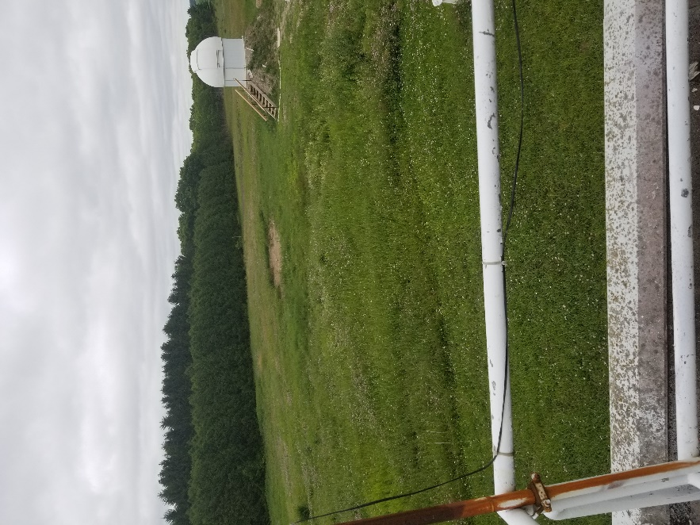

## Figure 3: Picture from Elgin Observatory mid level deck

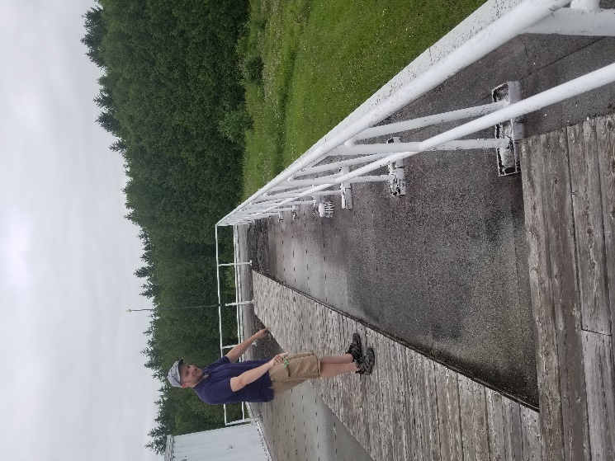

## Figure 4: Elgin Observatory Sun Deck

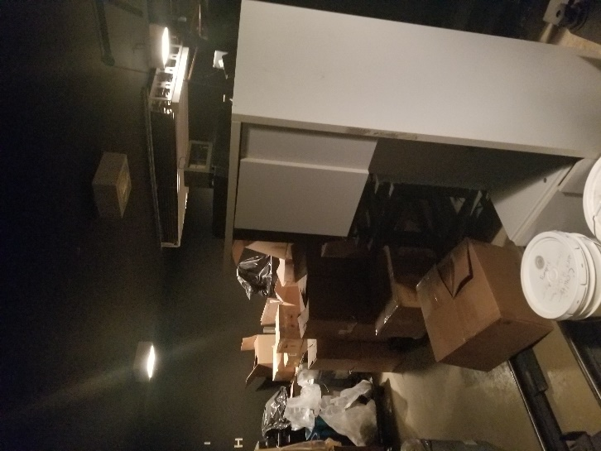

Figure 5: Elgin observatory storage space

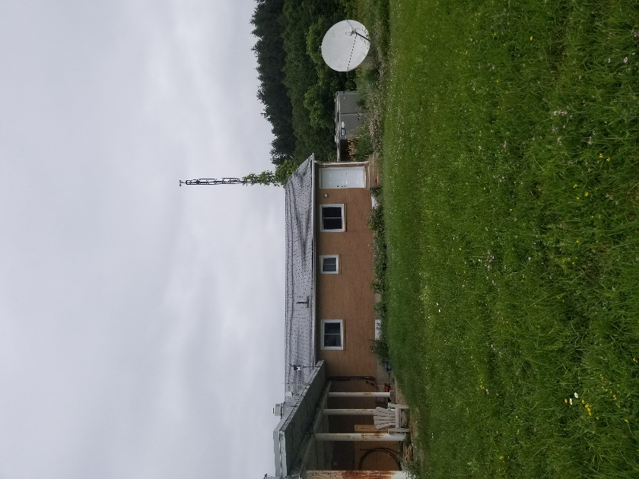 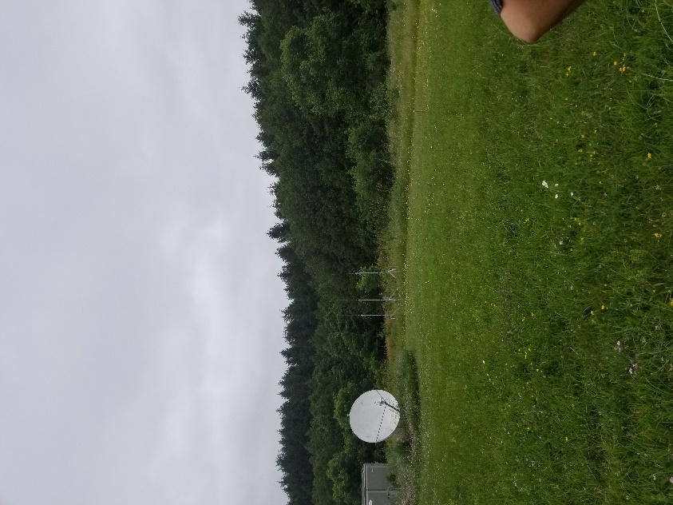

## Figure 6 and 7: Elgin Observatory house and surrounding treeline

## 

## Figure 8: Elgin Observatory external platform